Digital Clipboard (Booper) How-To:

Contents

Warning: 1

Running / Open: 1

Scanning ECN: 1

Submit Check-In/Check-Out: 2

Closing: 2

# Warning:

The Digital Clipboard is still in development and needs feedback to help further the effectiveness it will provide to the targeted audience. If you encounter a defect/flaw/issue of any kind, please provide feedback on how to recreate the issue, what information you were using at the time, and any other information that might be of value to fixing that issue. Thank you for your patience and I hope you find value in this application.

# Running / Open:

* Make sure you have a camera enabled or plugged in before trying to start the application.
* To run/open the application, there should be a batch file on the desktop for the Digital Clipboard, double click this batch file to run it.
  + Once you have double clicked the batch file a cmd prompt will appear to show you the Digital Clipboards logs. You do not need to worry about these logs if they display errors, unless the application is doing something that is not expected.

# Scanning ECN:

* To scan an ECN, place the device barcode/QR code in front of the camera and look at the window that displays the video feed. If the barcode/QR code is blurry you may have to adjust the distance from the camera before it can recognize it.
* Once the application has recognized the barcode/QR code it will draw a green square/rectangle around it and pause the video feed.
  + 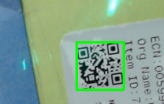
  + [Image of barcode with green square around it]
* The application will open a window to display the barcode, and various input fields to record the data for this device. Please fill out these fields and use the command buttons below the fields to submit the record.

# Submit Check-In/Check-Out:

* 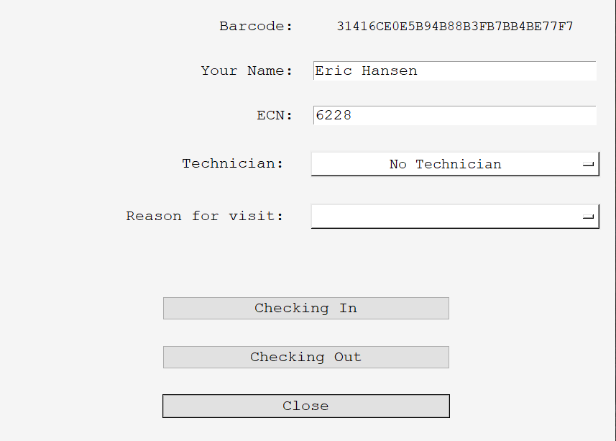
* The Digital Clipboard submission window will have different fields to collect from the user.
* These fields include: Name, ECN, Technician, Reason for visit, and buttons to Check-In or Check-Out.
* Required Information before the record is submitted
  + Check-In Requirements:
    - Name
    - ECN
    - Technician
    - Reason for visit
  + Check-Out Requirements:
    - Name
    - ECN
    - Technician
    - Signature
* When checking in a device, no signature is needed, but when checking out a device a signature window will appear and allow the user to sign.
* The Digital Clipboard has validation in place in order to get the required information before allowing a submission.

# Closing:

* The Digital Clipboard was created to be running constantly with little delays between scans. That means when you click on the “X” in the top right of the application window it will only close that current window, but will continue to run.
  + 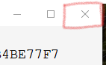
* To close the entire application you can:
  + Click the “Close” button on the check-in/check-out window.
  + Focus the cmd window use the keyboard combination “Ctrl-C” and then type “Y” to terminate processes.
  + If these are not working, you can also try focusing the video feed and hitting the “Esc” key which should bring you to the check-in/check-out window where you can hit the “Close” button.